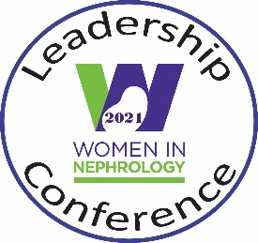
2022 WIN Leadership Conference
2022
“WIN’ing Strategies to Lead Successfully in Nephrology”
September 23-24, 2022
Birmingham, AL

Dependent Care Grants
Application

WIN recognizes the challenge posed by dependent care on one’s ability to attend national conferences. This grant is intended to provide an offset of costs incurred by the applicant so that she/he can attend the 2022 WIN Leadership Conference.

Family Care Grants for up to $250 per family are available for the 2022 WIN Leadership Conference attendees. The purpose of the grant is to provide families with flexible financial assistance that can be applied towards extra expenses incurred for dependent care during the meeting, either at the meeting location or the home location, as determined by the applicant.
Awardees are responsible for making their own family care arrangements.
WIN assumes no responsibility with respect to any dependent care services and accepts no liabilities related to the services provided.
Eligibility:
- Applicants must be members in good standing
- Applicants must have registered for the meeting
- Families are eligible for one grant per member per year.
- Eligible applications are approved on a first-come, first-serve basis.
Please email your application to win@womeninnephrology.org by September 1, 2022. Applicants receive notification of the status of their grants no later than one week prior to the event start date.

Please provide a dependent care statement (3-4 sentences) below regarding your circumstances with respect to your attendance at the conference:

