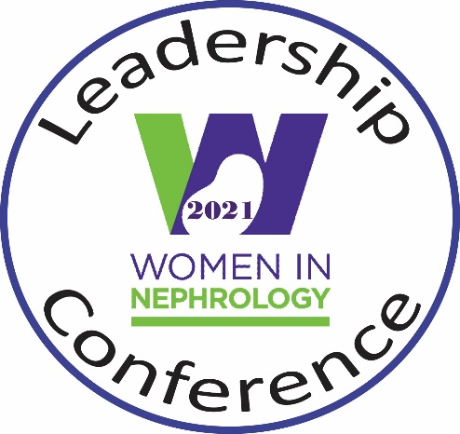
2022
“WIN’ing Strategies to Lead Successfully in Nephrology”
September 23-24, 2022
Birmingham, AL

Call for Abstracts
Poster Session
Friday, September 23, 2022
4:45-5:30PM
Hilton Birmingham at UAB

Abstracts can be traditional in the sense of basic or clinical research projects but can also highlight leadership or career development initiatives, social sciences or humanism topics related to medicine, diversity projects, or medical education

Monetary Awards will be given for top posters
Innovation, cutting-edge research, leadership, equity in the workplace

Deadline: Friday, September 2nd, 6pm CST *
*Abstracts will be approved on a rolling basis.
Abstracts from recent conferences may be submitted.

Submission guidelines:
- Complete application including abstract, description of leadership aspirations and CV. Please see application materials below. Email with any questions: win@womeninnephrology.org
- Fellows: include Program Director/Supervisor Attestation
- Please include title, authors and affiliated institutions, background, methods, results and conclusions sections
- Email application to Dr. Emily Zangla: zangl015@umn.edu
APPLICATION TO PRESENT RESEARCH or SCHOLARSHIP
at
2022 WOMEN IN NEPHROLOGY LEADERSHIP CONFERENCE
September 23 & 24, 2022
Birmingham, AL
“WIN’ing Strategies to Secure Leadership Roles in Nephrology”

ELIGIBILITY: 1) postdoctoral fellow trainee or junior faculty members that have completed training within the last 7 years.

2) mandatory meeting registration.

INSTRUCTIONS: complete this 5 page application and submit with your CV to: zangl015@umn.edu

APPLICATION DEADLINE: September 2, 2022

Name: ______________________________________________________________
I am applying for:
☐ Scholarship presentation only (poster presentation summarizing a quality improvement project, research project or an educational project)
☐ Scholarship presentation & Travel Award ($625)

Gender: ☐ Female ☐ Male ☐ Non-binary ☐ Prefer not to answer
Preferred pronouns:  ☐ She/her/hers  ☐ He/him/his  ☐ They/them/their  ☐ Other  ☐ Prefer not to answer | Race [check all that apply]:  ☐ White or European American  ☐ Black or African American  ☐ American Indian  ☐ Alaska Native/Native Hawaiian or other Pacific Islander  ☐ Asian American  ☐ More than one race  ☐ Prefer not to answer

Ethnicity:
☐ Hispanic/LatinX
☐ Non-Hispanic/LatinX
☐ Other
☐ Prefer not to answer

Degree(s):
☐ MD/DO/MBBS
☐ PhD
☐ MD/PhD
☐ Other _______________________

Year terminal degree was received: _______
Year terminal training was completed (if a junior professional): ______
Current position (title/organization): _______________________________________
_______________________________________
City/State of current position: _______________________________________
Career Stage:
☐ 1st year fellow  ☐ 2nd year fellow  ☐ 3+ year fellow  ☐ Pre-doctoral student (MD or PhD) | ☐ Post-doctoral trainee (MD or PhD)  ☐ Clinical/research instructor  ☐ Assistant professor  ☐ Other (i.e., junior professional not in academia)

Career path:
☐ Clinician
☐ Clinician- educator
☐ Clinician – administrator
☐ Physician -scientist (clinical or basic research)
☐ Scientist (clinical or basic research)
☐ Industry/pharmaceutical

Abstract (e.g., research, education, or quality improvement projects, limited to 250 words):

Please describe your leadership aspirations, why you wish to attend this conference and how the conference will benefit your career (limited to 500 words)

Program Director/Supervisor Attestation:
☐ Not applicable. Applicant is not in training
☐ Applicable. Applicant is currently in training (please complete the items below)

For clinical and research postdoctoral trainees (MD and PhD), please confirm that the applicant will have the protected time needed to attend this conference:

If given the opportunity for this presentation, I agree that this trainee applicant will receive the needed time off to attend the entire conference.
Signature of Program Director/Supervisor: ______________________________________

